**Description**

As a user I should be able to see the list so that I can create new activity .

------------------------------------------------------------------------------------------------------------------------------------------

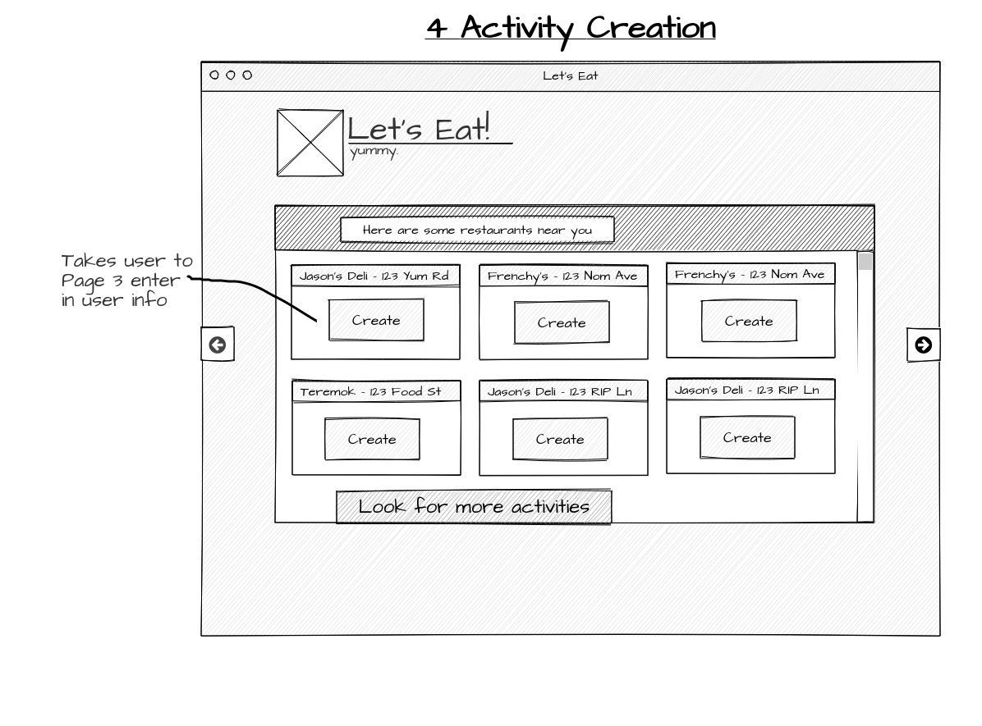

**Acceptance criteria**

* Should display list to create activity .
* Each option should display button “create”
* When “Create” button is clicked it should display User Information page.